Module**-6: Ansible Assignment – 1**

● Setup Ansible cluster with 3 nodes

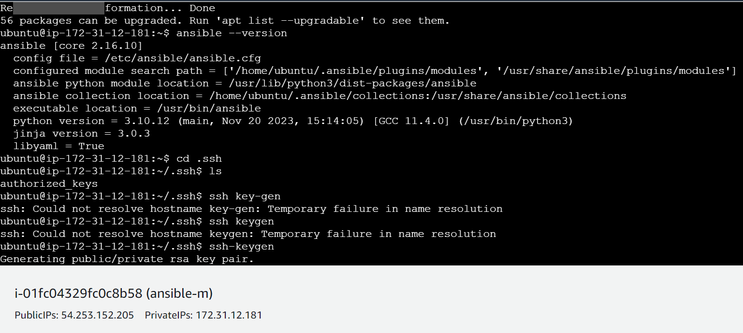

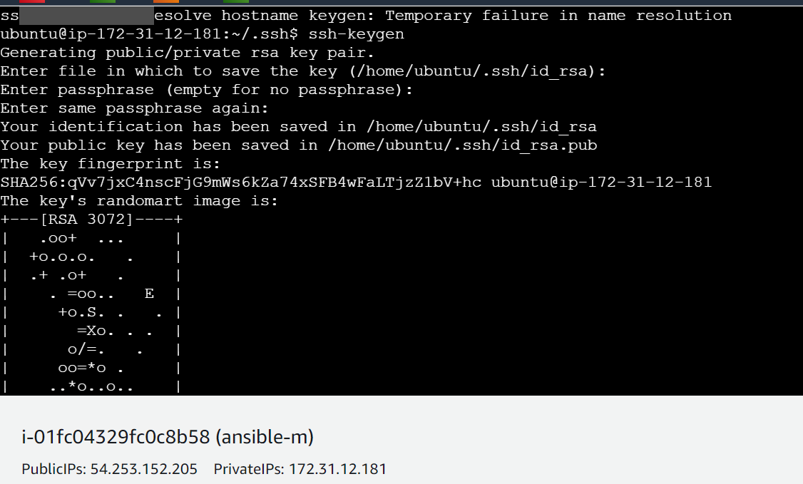

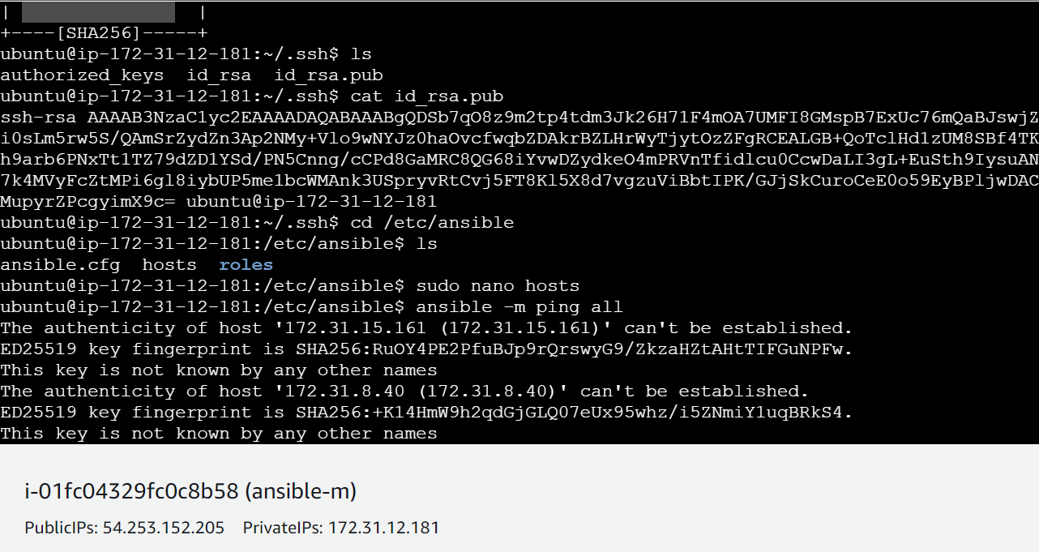

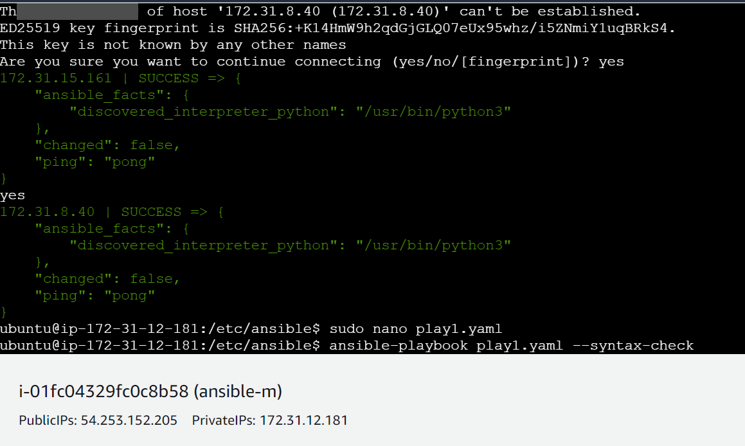

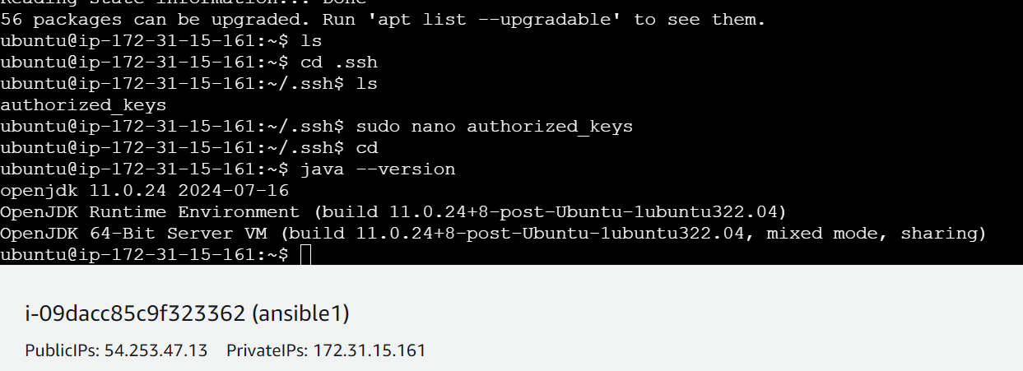

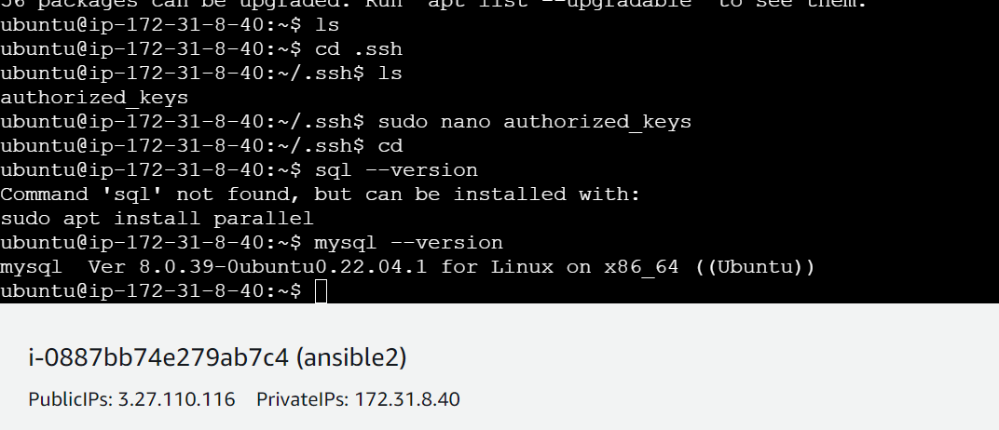

● On slave1 install java

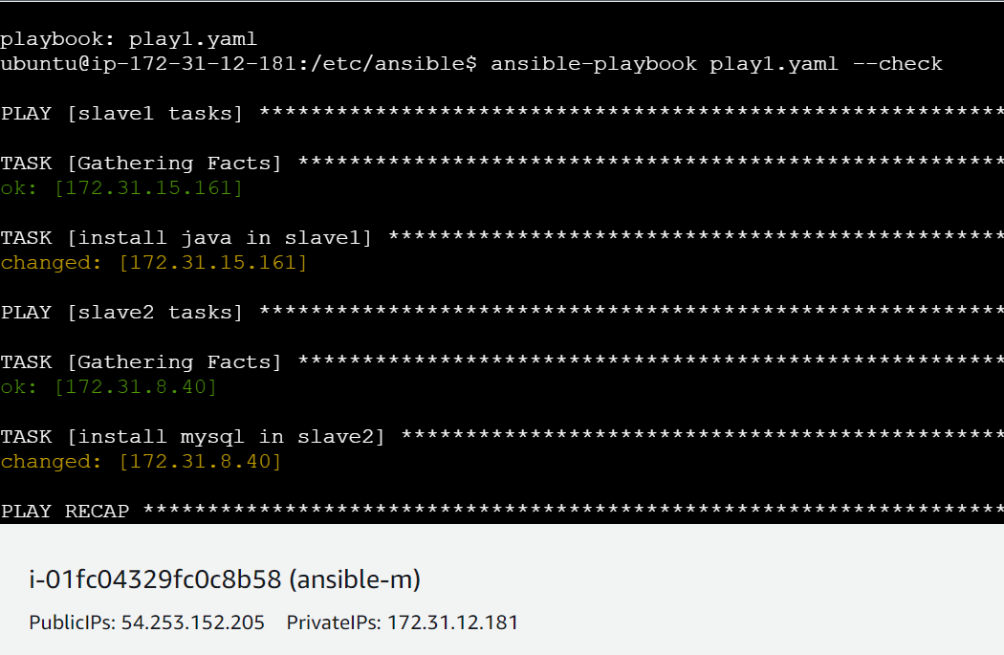

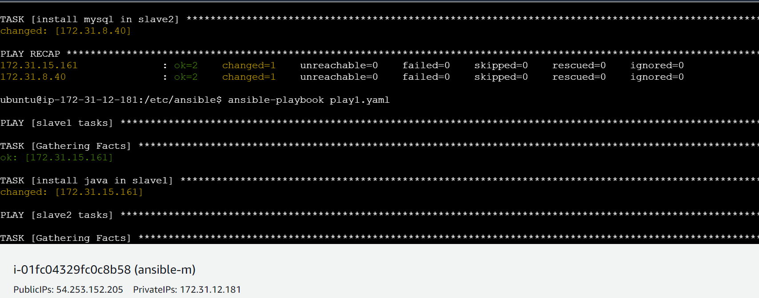

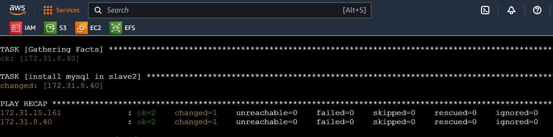

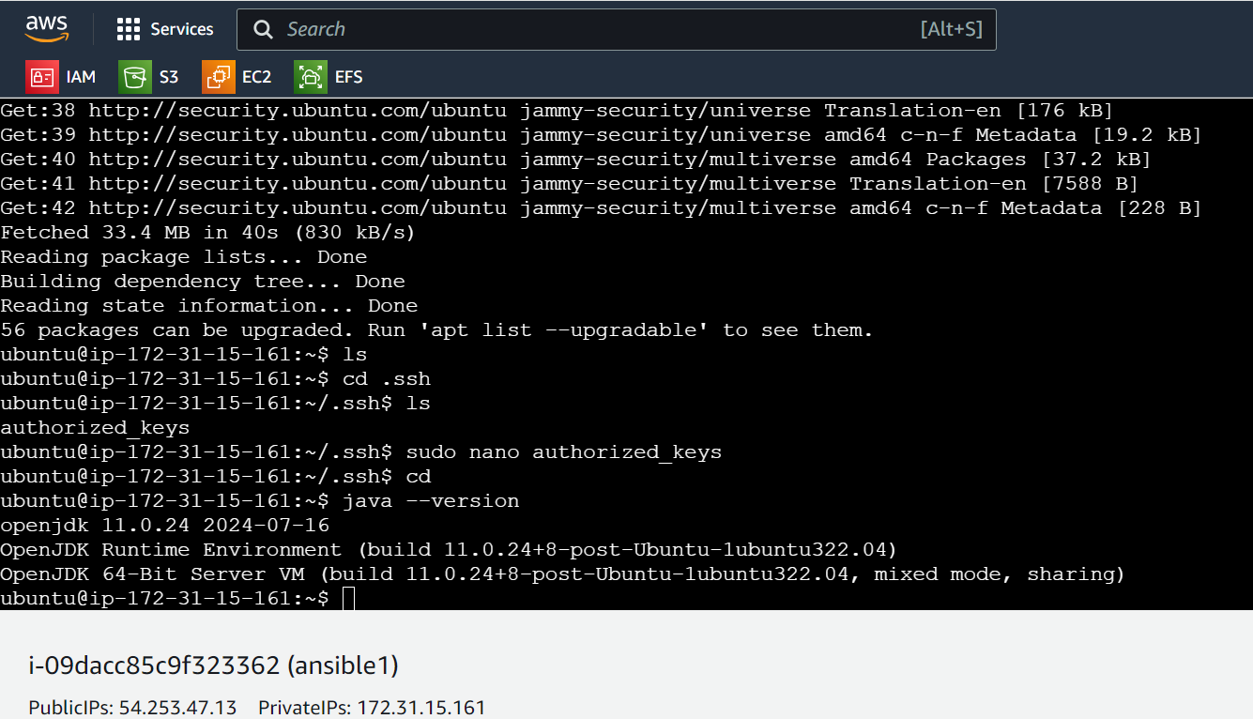

● On slave 2 install mysql-server

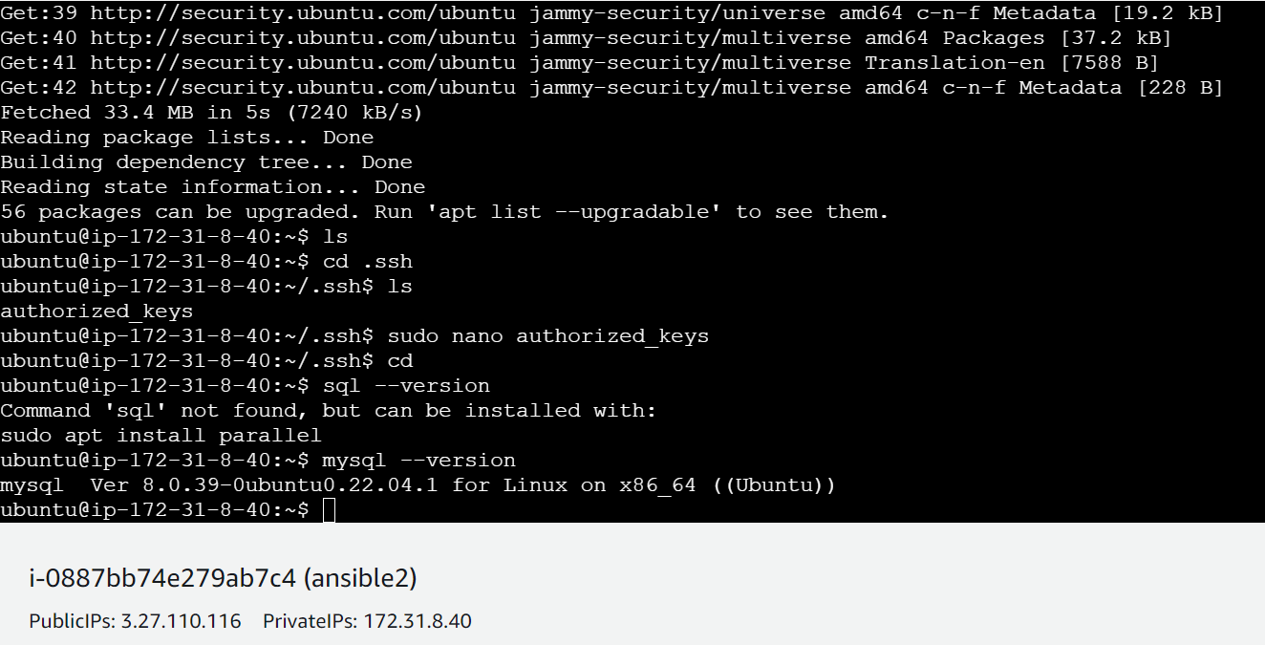

Play1.yaml –

---

- name: task for slave1

hosts: java

become: true

tasks:

- name: install java in slave1

apt: name=openjdk-11-jdk state=latest

- name: task for slave2

hosts: sql

become: true

tasks:

- name: install mysql in slave2

apt: name=mysql-server state=latest

History-

1 sudo apt update

2 sudo apt install software-properties-common

3 sudo add-apt-repository --yes --update ppa:ansible/ansible

4 sudo apt install ansible

5 sudo apt-update

6 sudo apt update

7 ansible --version

8 cd .ssh

9 ls

10 ssh key-gen

11 ssh keygen

12 ssh-keygen

13 ls

14 cat id_rsa.pub

15 cd /etc/ansible

16 ls

17 sudo nano hosts

18 ansible -m ping all

19 sudo nano play1.yaml

20 ansible-playbook play1.yaml --syntax-check

21 sudo nano play1.yaml

22 ansible-playbook play1.yaml --check

23 ansible-playbook play1.yaml

24 sudo nano play1.yaml

25 ansible-playbook play1.yaml --syntax-check

26 ansible-playbook play1.yaml --check

27 ansible-playbook play1.yaml

28 cd

29 history

**Module-6: Ansible Assignment – 2**

● Create a script which can add text “This text has been added by custom script” to /tmp.1.txt

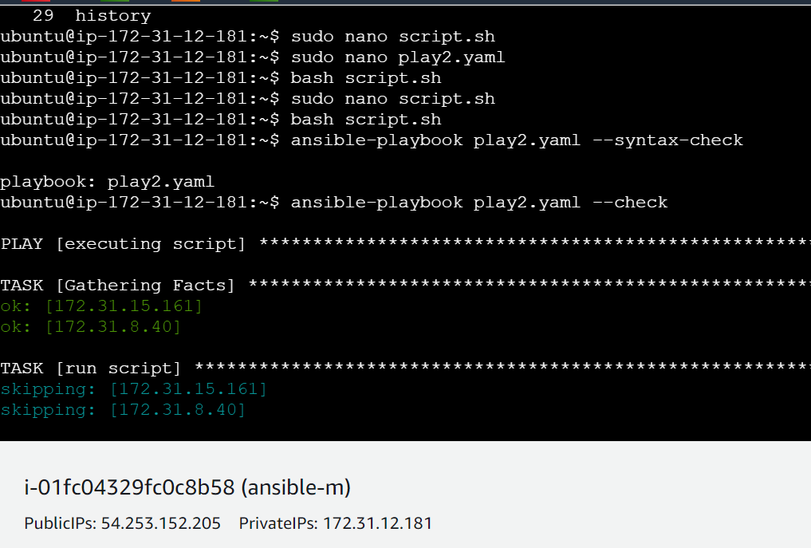

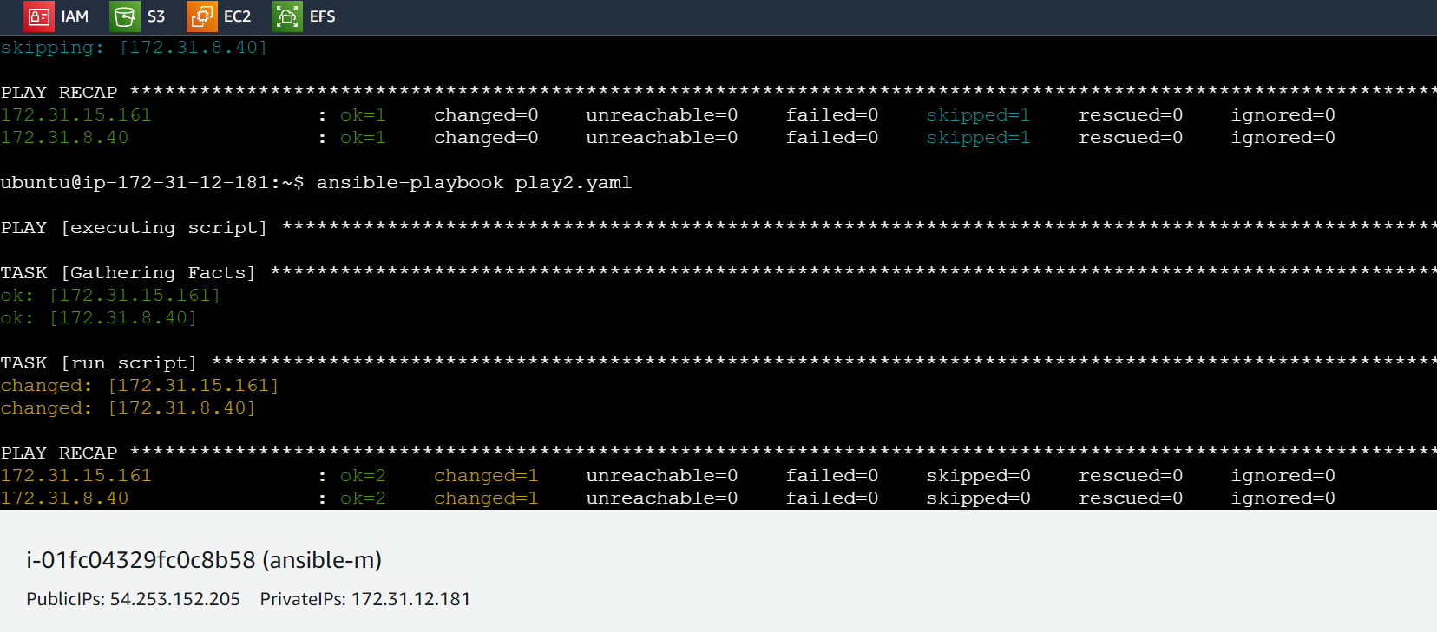

● Run this script using Ansible on all the hosts

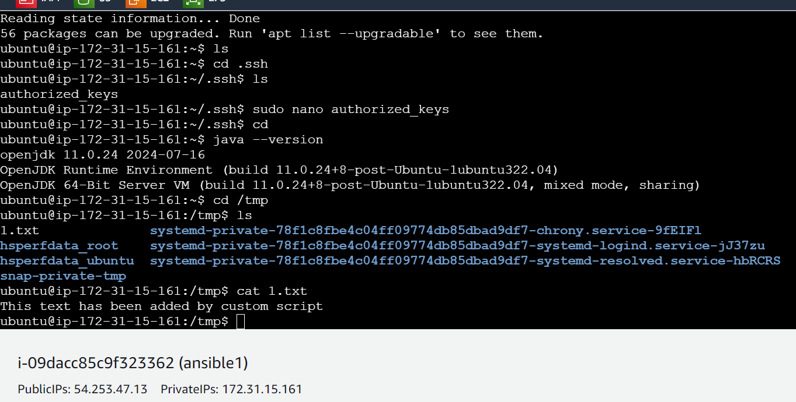

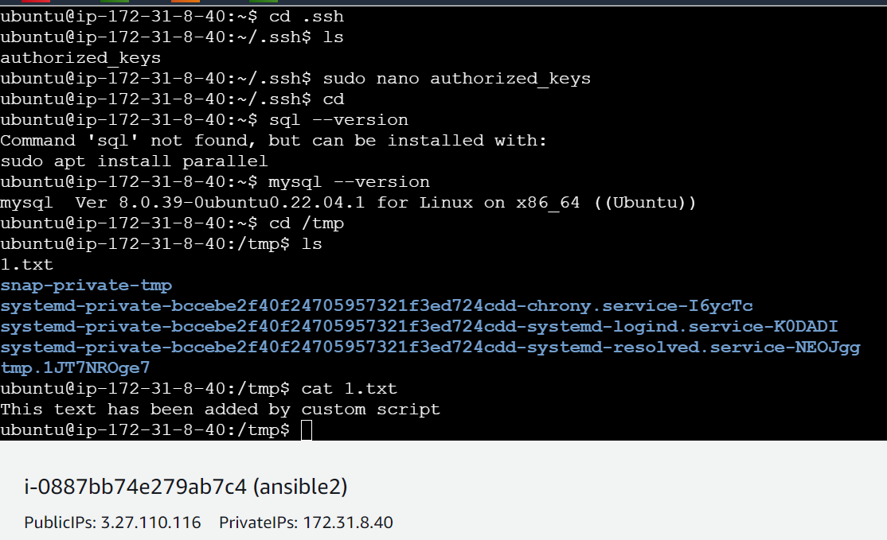

Play2.yaml –

---

- name: executing script

hosts: all

become: true

tasks:

- name: run script

script: script.sh

History –

30 sudo nano script.sh

31 sudo nano play2.yaml

32 bash script.sh

33 sudo nano script.sh

34 bash script.sh

35 ansible-playbook play2.yaml --syntax-check

36 ansible-playbook play2.yaml --check

37 ansible-playbook play2.yaml

38 history

**Module-6: Ansible Assignment – 3**

● Create 2 Ansible Roles

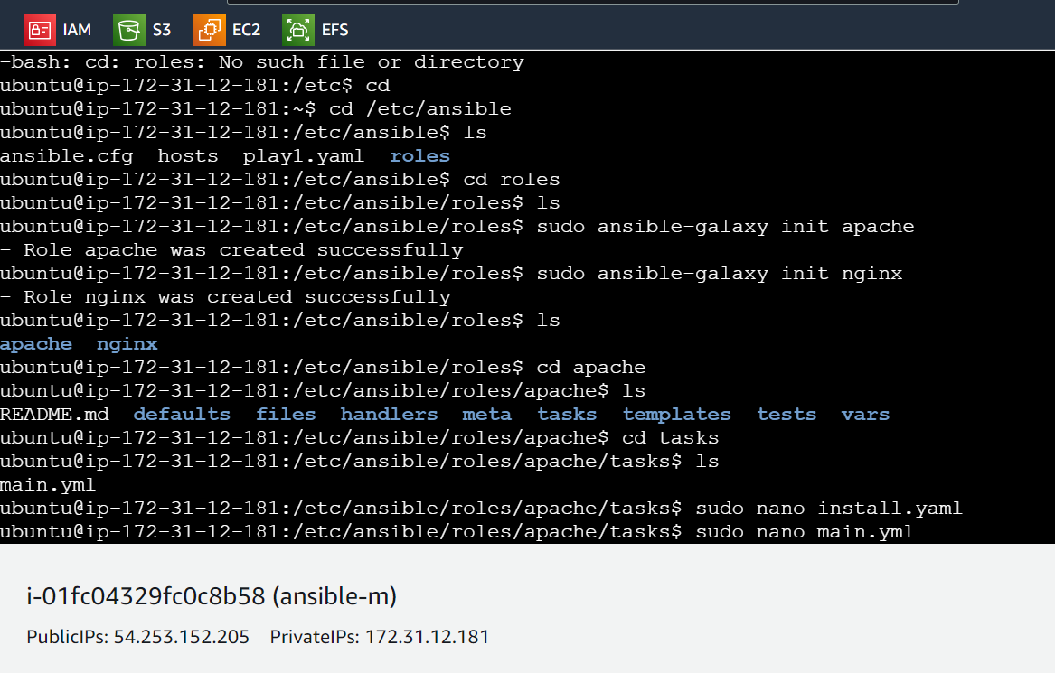

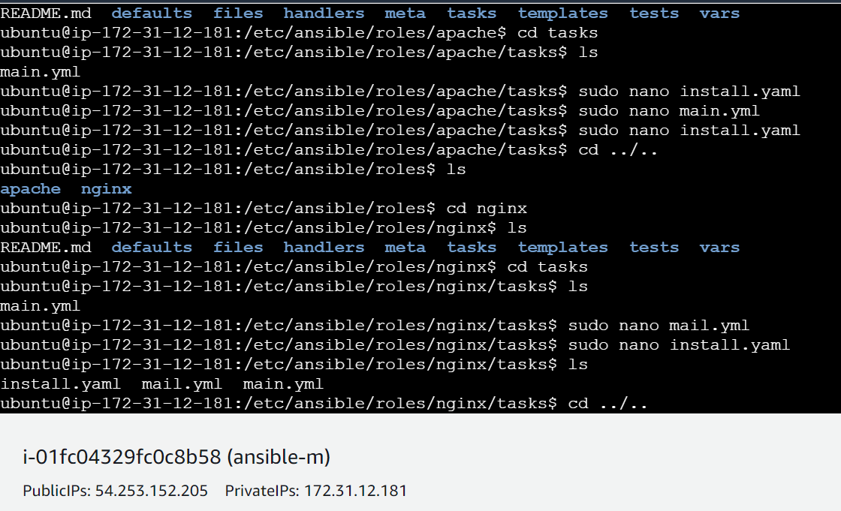

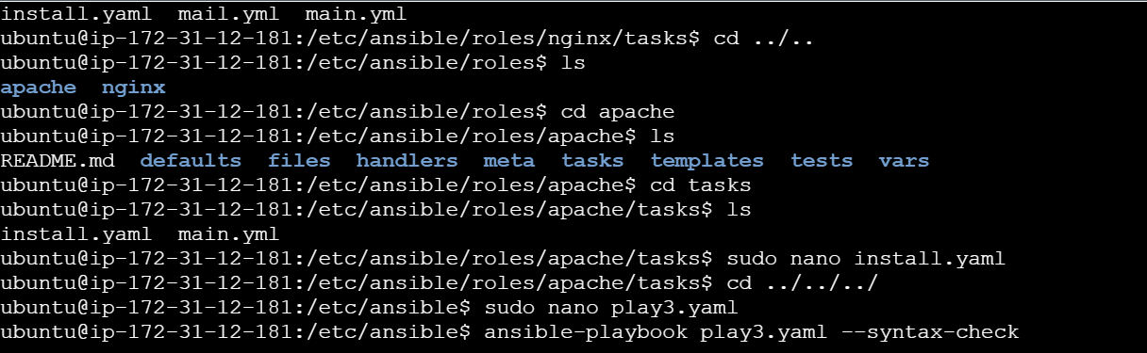

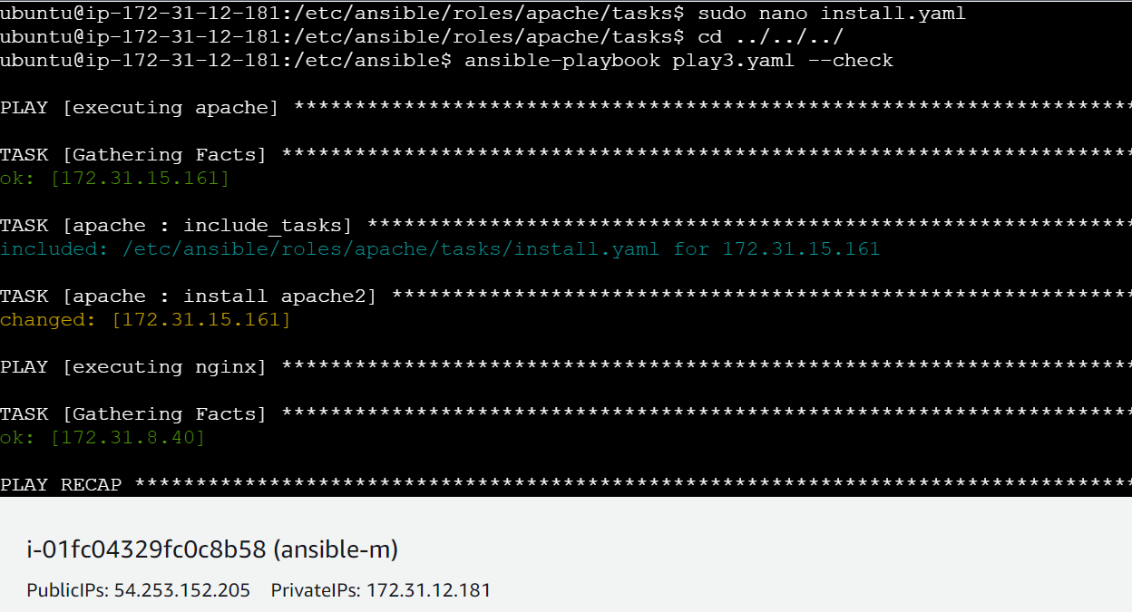

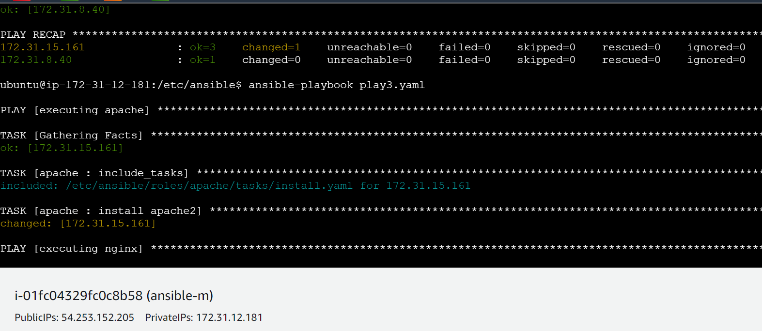

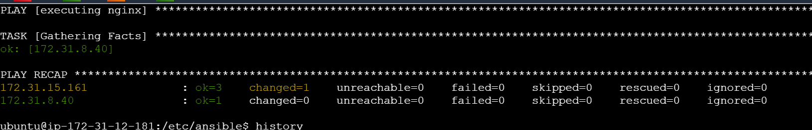

● Install apache2 on slave1 using one role and nginx on slave2 using the other role

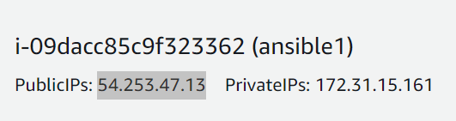

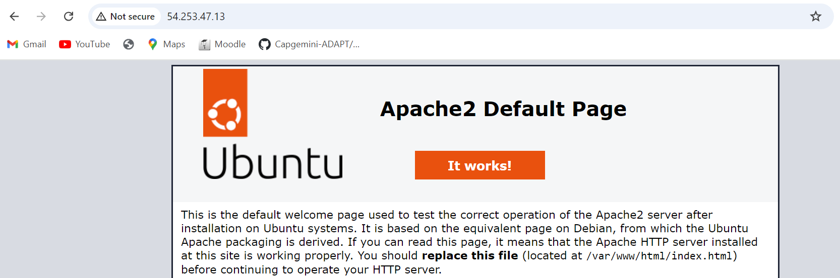

Play3.yaml –

---

- name: executing apache

become: true

hosts: java

roles:

- apache

- name: executing nginx

become: true

hosts: sql

roles:

- nginx

History –

44 cd /etc/ansible

45 ls

46 cd roles

47 ls

48 sudo ansible-galaxy init apache

49 sudo ansible-galaxy init nginx

50 ls

51 cd apache

52 ls

53 cd tasks

54 ls

55 sudo nano install.yaml

56 sudo nano main.yml

57 sudo nano install.yaml

58 cd ../..

59 ls

60 cd nginx

61 ls

62 cd tasks

63 ls

64 sudo nano mail.yml

65 sudo nano install.yaml

66 ls

67 cd ../..

68 ls

69 cd apache

70 ls

71 cd tasks

72 ls

73 sudo nano install.yaml

74 cd ../../../

75 sudo nano play3.yaml

76 ansible-playbook play3.yaml --syntax-check

77 ansible-playbook play3.yaml --check

78 cd /etc/ansible

79 ls

80 cd roles

81 ls

82 cd apache

83 ls

84 cd tasks

85 ls

86 sudo nano mail.yaml

87 ls

88 sudo nano mail.yml

89 ls

90 sudo nano main.yml

91 sudo nano install.yaml

92 cd ../../../

93 ansible-playbook play3.yaml --check

94 ansible-playbook play3.yaml

95 history

**Module-6: Ansible Assignment – 4**

● Use the previous deployment of ansible cluster

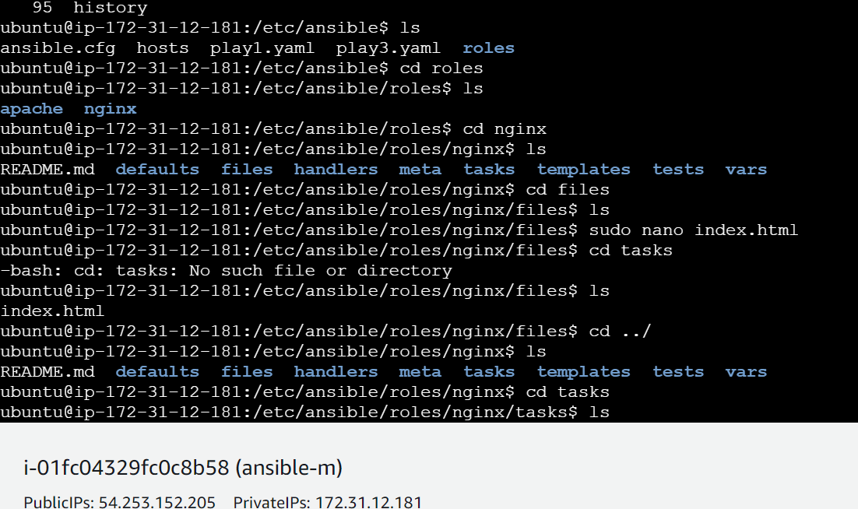

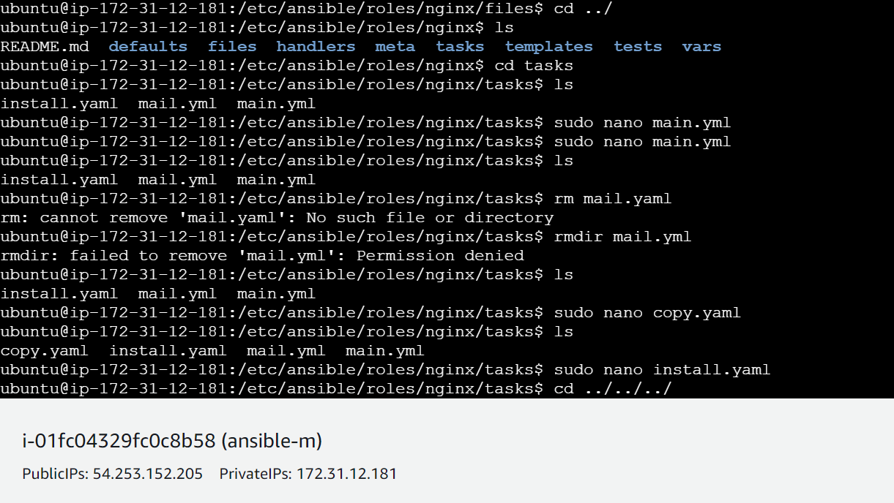

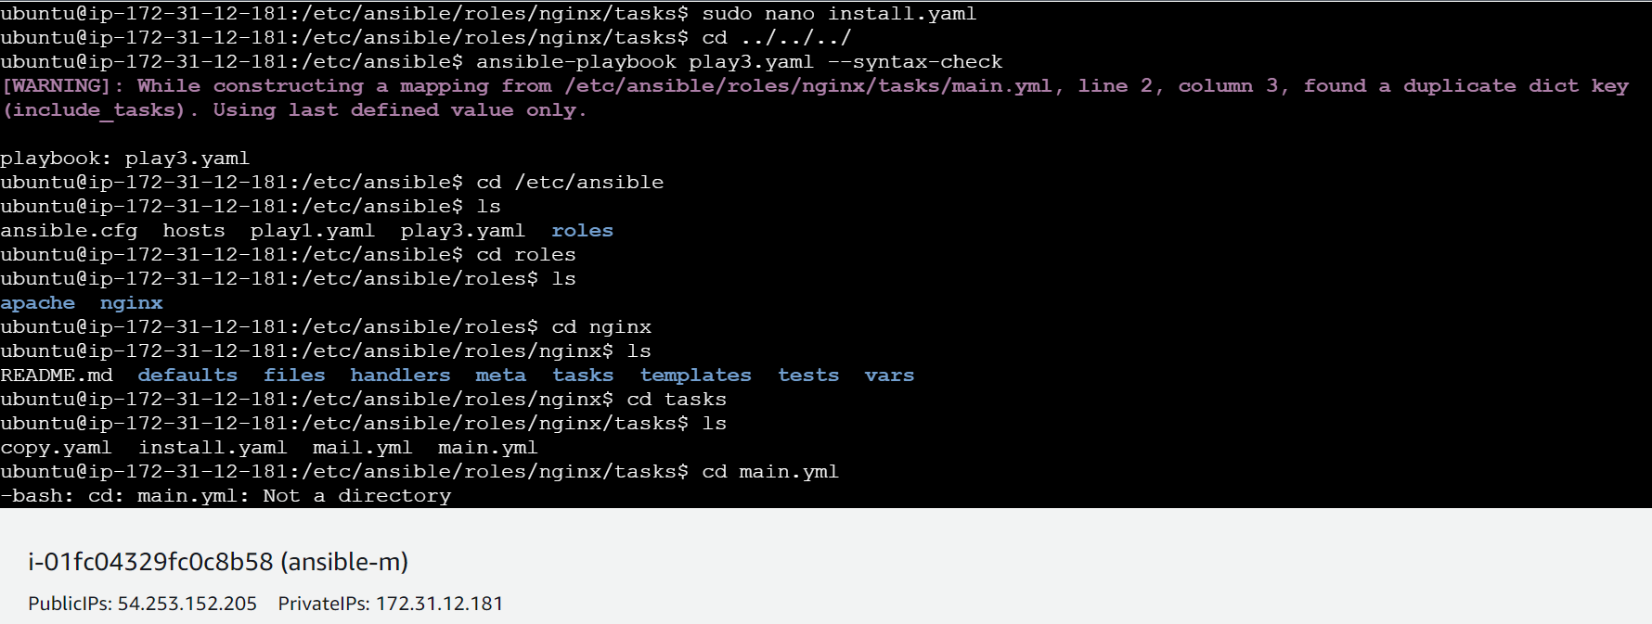

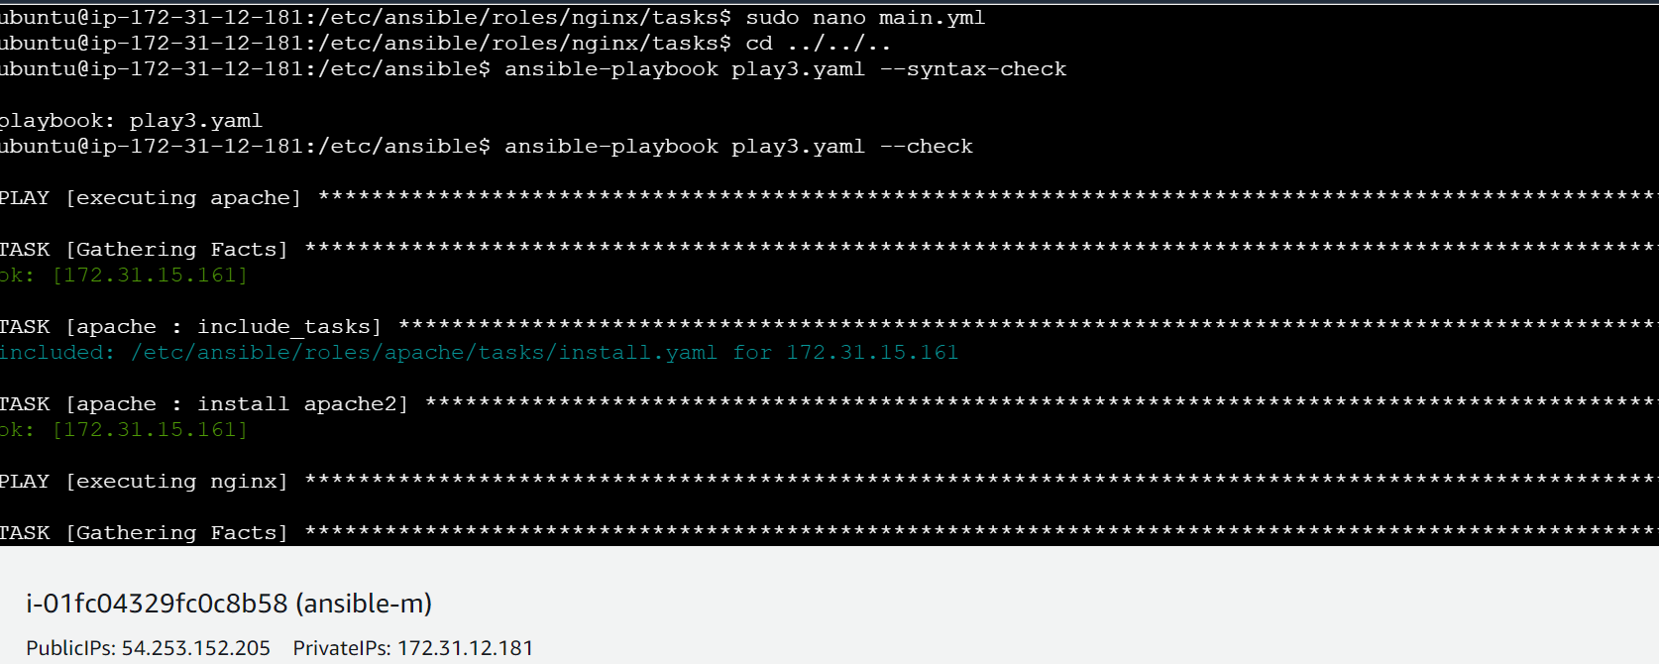

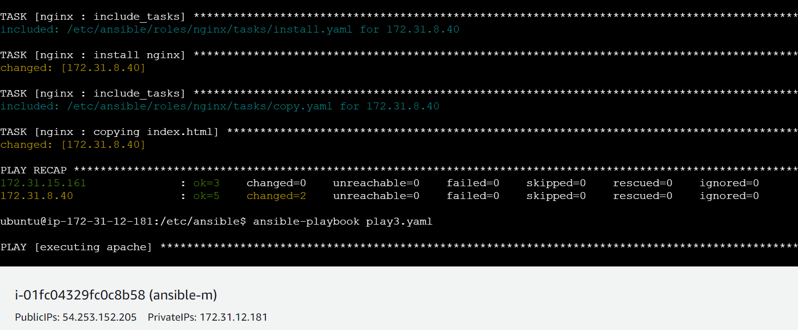

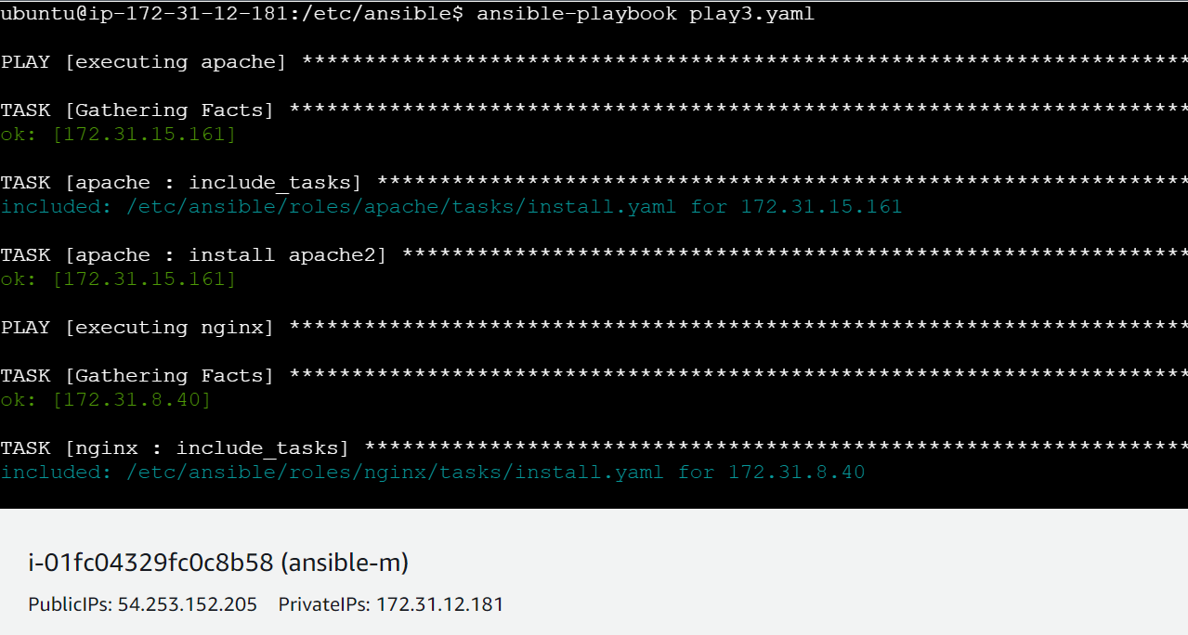

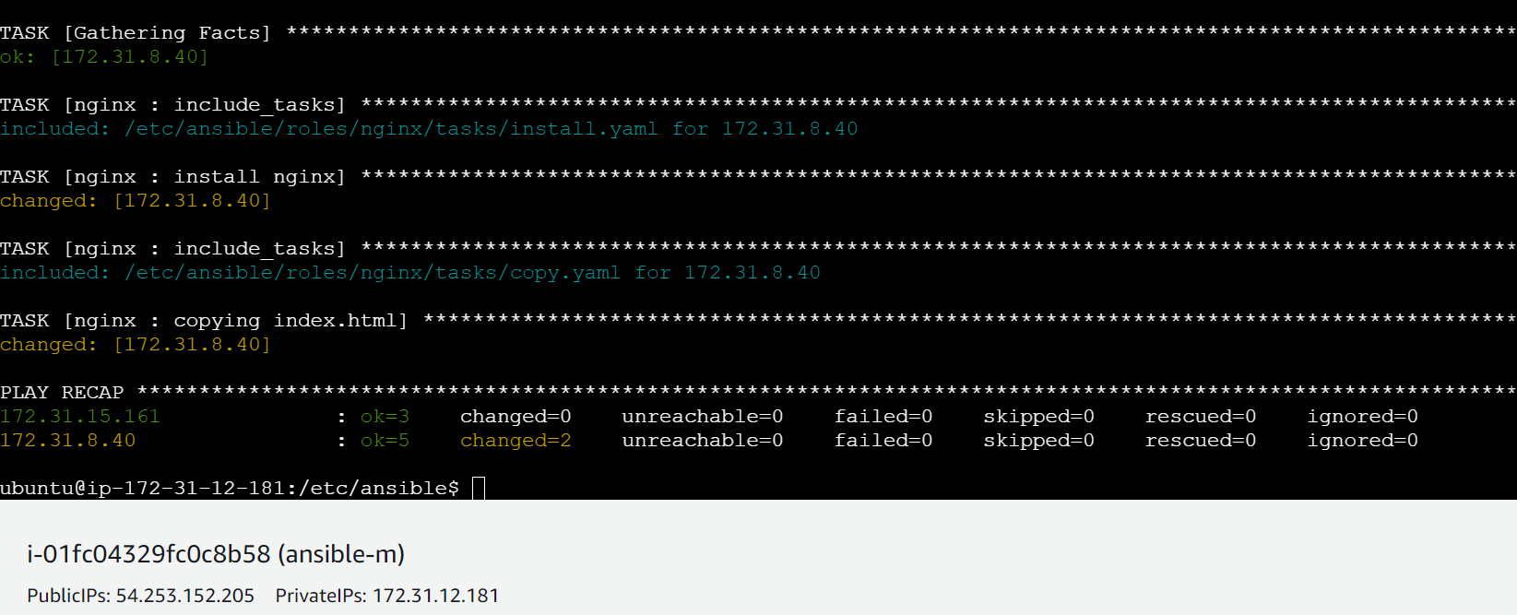

● Configure the files folder in the role with index.html which should be replaced with the original index.html

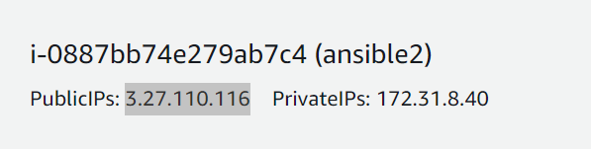



History –

97 cd roles

98 ls

99 cd nginx

100 ls

101 cd files

102 ls

103 sudo nano index.html

104 cd tasks

105 ls

106 cd ../

107 ls

108 cd tasks

109 ls

110 sudo nano main.yml

111 ls

112 rm mail.yaml

113 rmdir mail.yml

114 ls

115 sudo nano copy.yaml

116 ls

117 sudo nano install.yaml

118 cd ../../../

119 ansible-playbook play3.yaml --syntax-check

120 cd /etc/ansible

121 ls

122 cd roles

123 ls

124 cd nginx

125 ls

126 cd tasks

127 ls

128 cd main.yml

129 sudo nano main.yml

130 cd ../../..

131 ansible-playbook play3.yaml --syntax-check

132 ansible-playbook play3.yaml --check

133 ansible-playbook play3.yaml

134 history

**Module-6: Ansible Assignment – 5**

● Create a new deployment of ansible cluster of 5 nodes

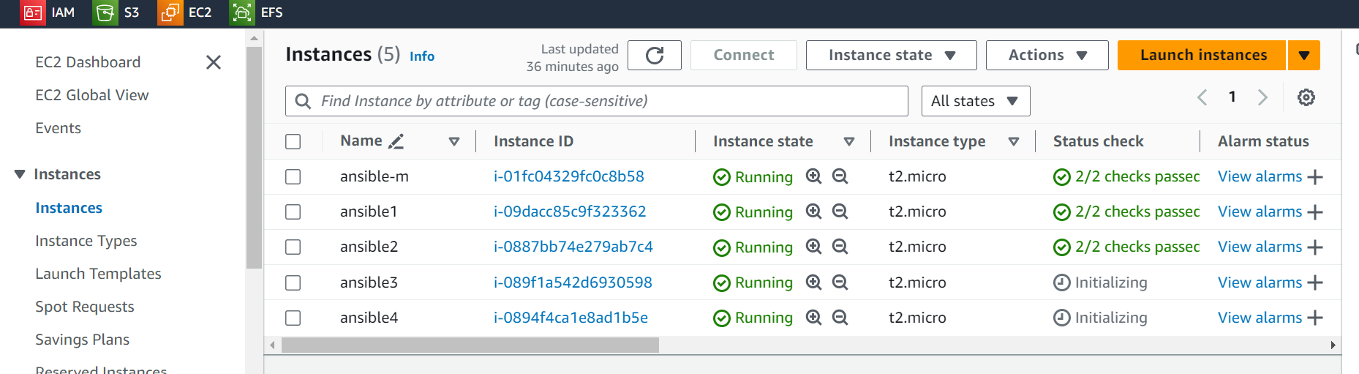

● Label 2 nodes as test and other 2 as prod

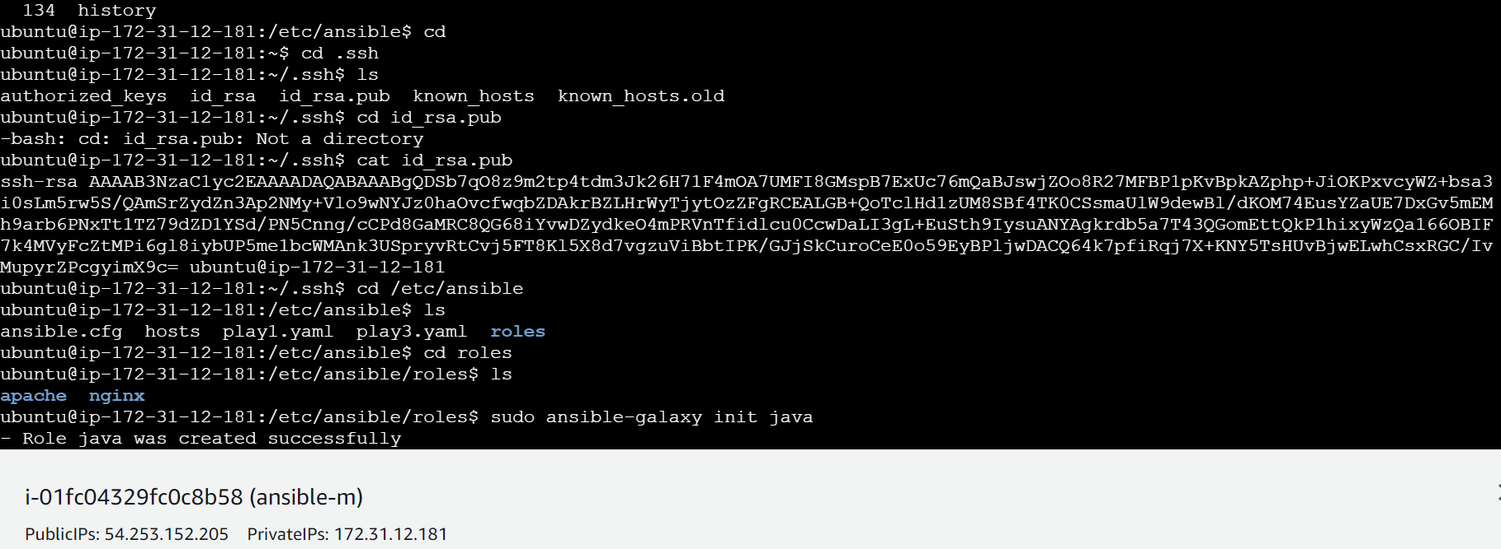

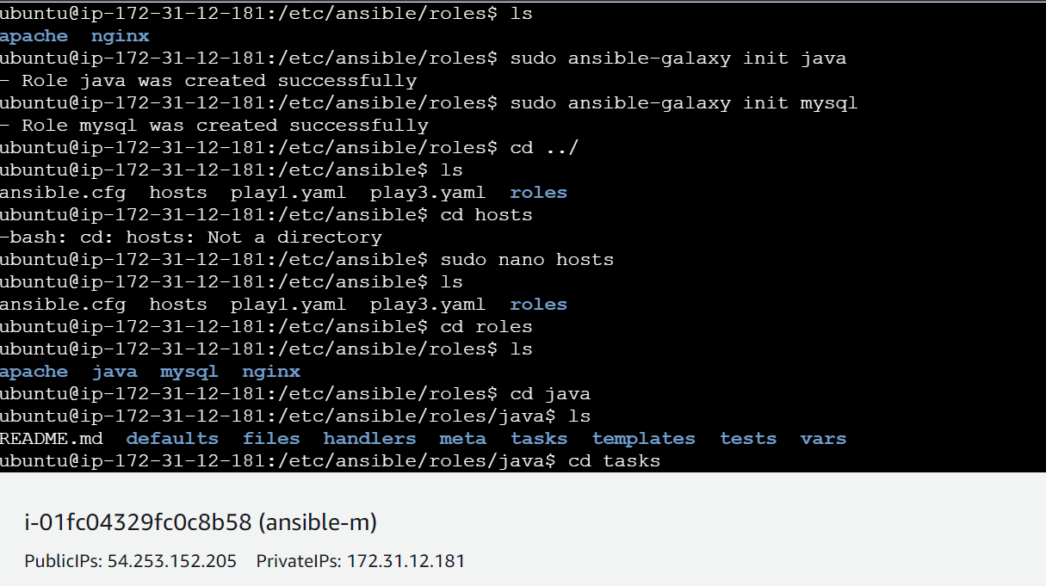

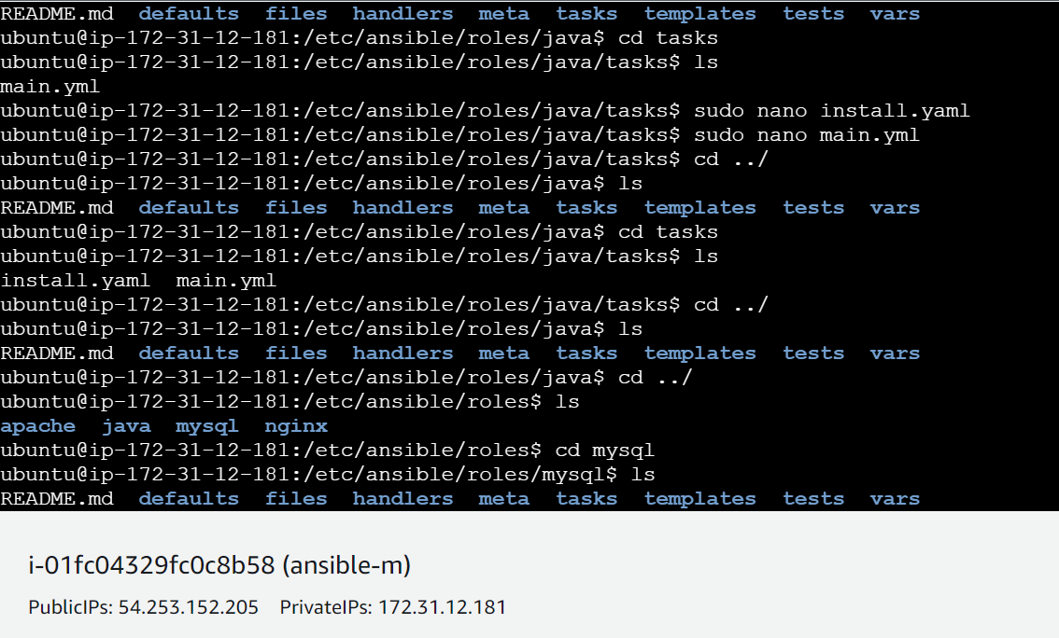

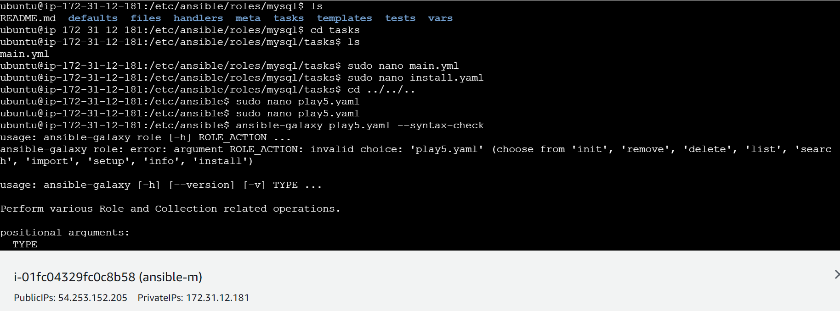

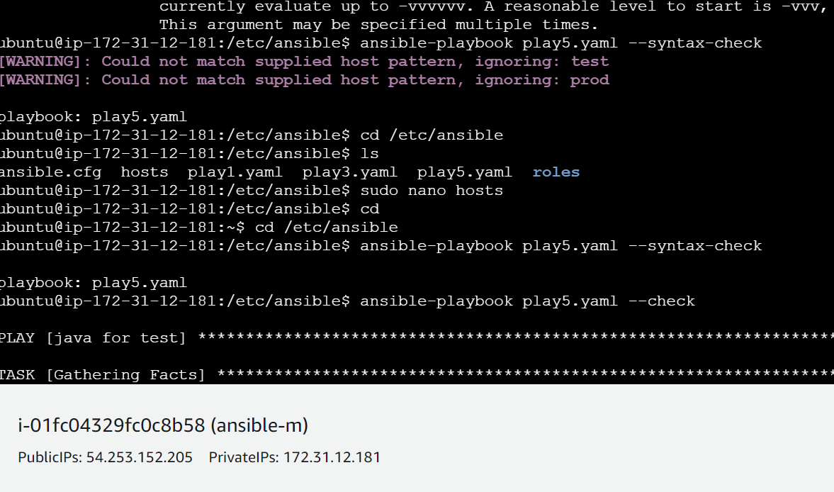

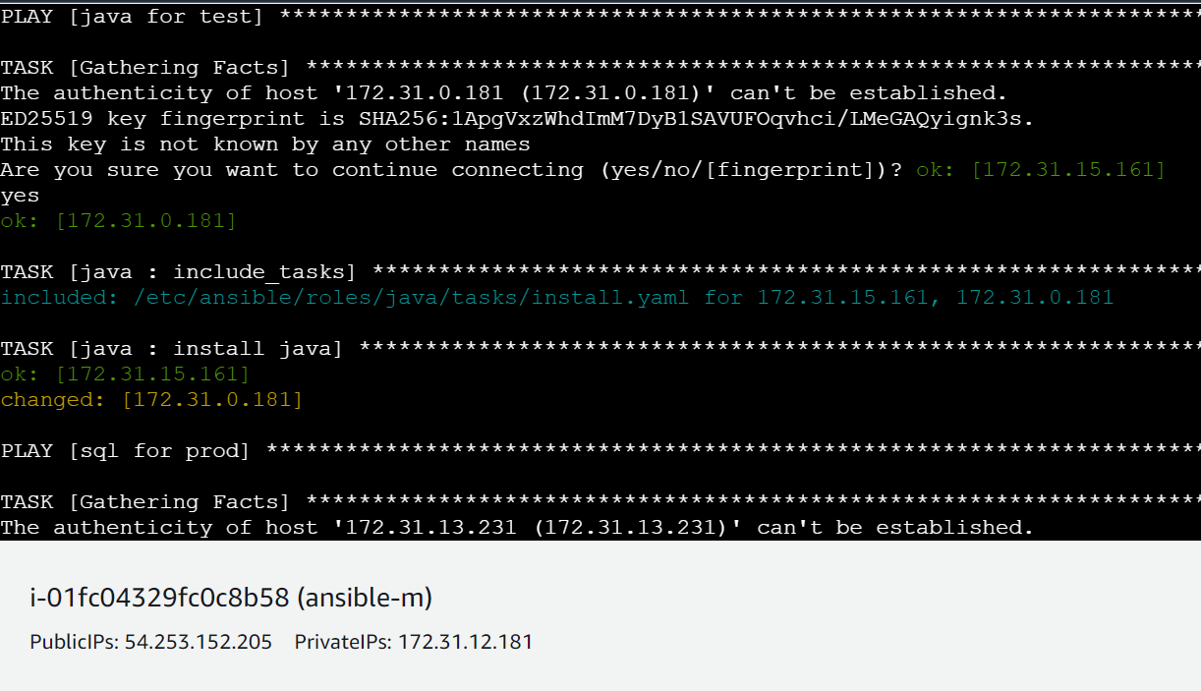

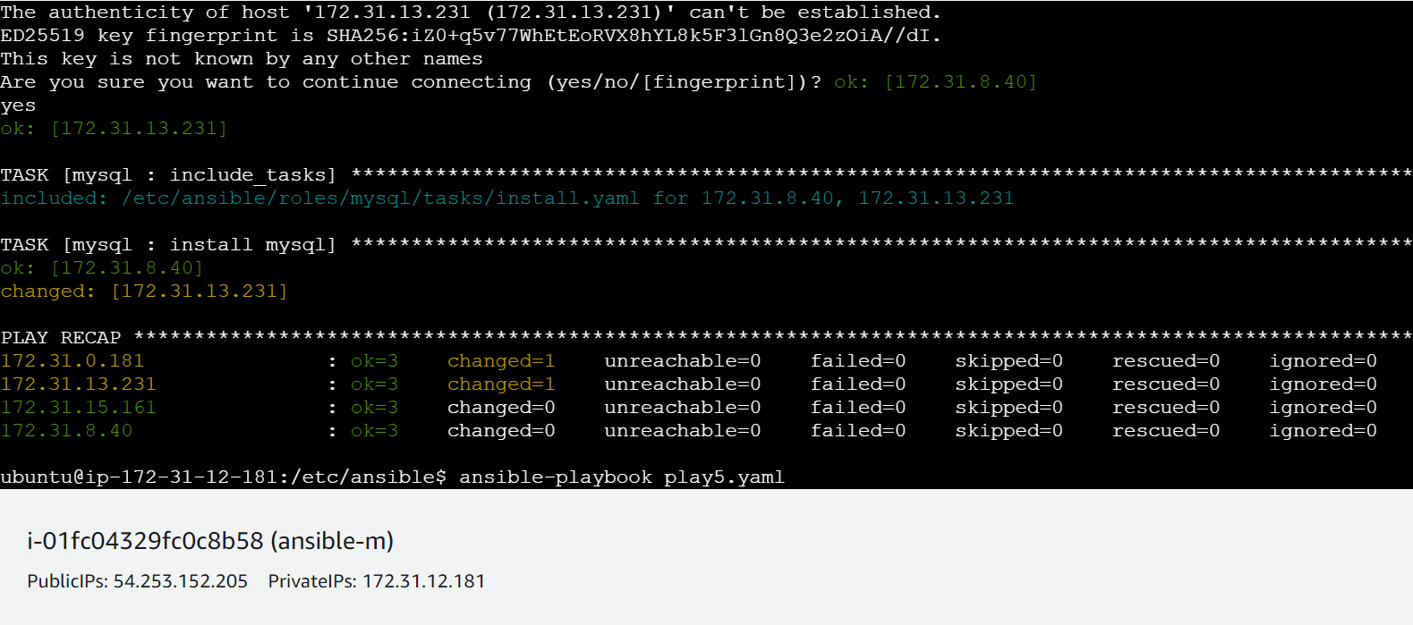

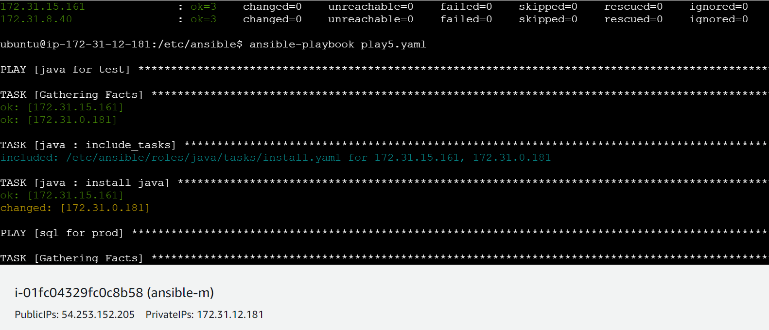

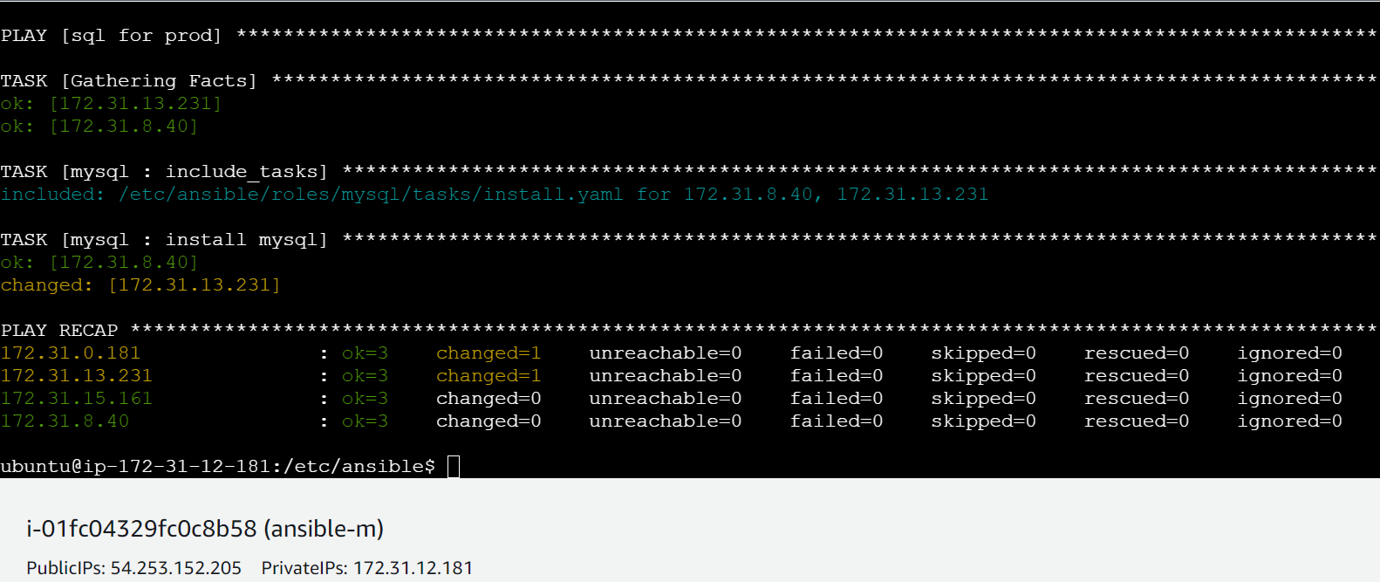

● Install java on test nodes

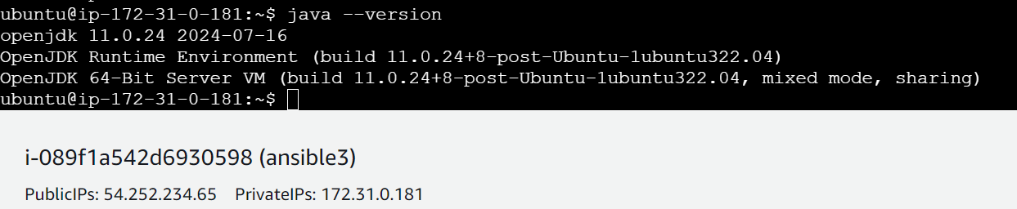

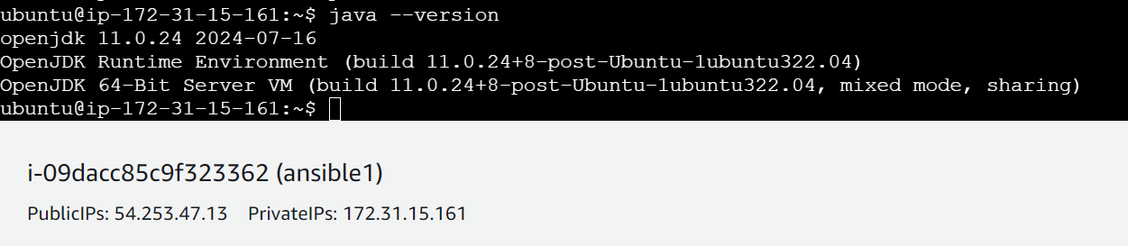

● Install mysql-server on prod nodes

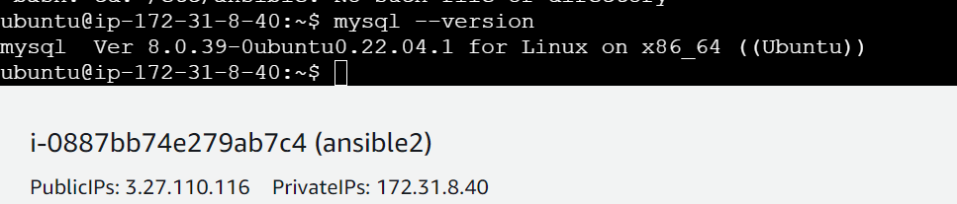

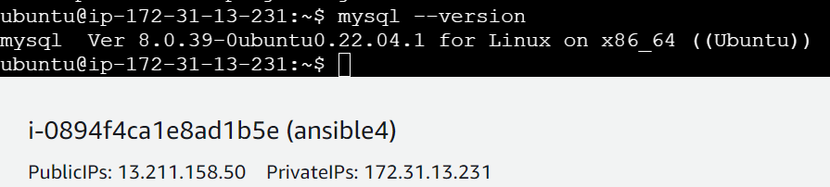

Play5.yaml –

---

- name: run java on test

hosts: test

become: true

roles:

- java

- name: run sql on prod

hosts: prod

become: true

roles:

- mysql

History-

135 cd

136 cd .ssh

137 ls

138 cd id_rsa.pub

139 cat id_rsa.pub

140 cd /etc/ansible

141 ls

142 cd roles

143 ls

144 sudo ansible-galaxy init java

145 sudo ansible-galaxy init mysql

146 cd ../

147 ls

148 cd hosts

149 sudo nano hosts

150 ls

151 cd roles

152 ls

153 cd java

154 ls

155 cd tasks

156 ls

157 sudo nano install.yaml

158 sudo nano main.yml

159 cd ../

160 ls

161 cd tasks

162 ls

163 cd ../

164 ls

165 cd ../

166 ls

167 cd mysql

168 ls

169 cd tasks

170 ls

171 sudo nano main.yml

172 sudo nano install.yaml

173 cd ../../..

174 sudo nano play5.yaml

175 ansible-galaxy play5.yaml --syntax-check

176 ansible-playbook play5.yaml --syntax-check

177 cd /etc/ansible

178 ls

179 sudo nano hosts

180 cd

181 cd /etc/ansible

182 ansible-playbook play5.yaml --syntax-check

183 ansible-playbook play5.yaml --check

184 ansible-playbook play5.yaml

185 history